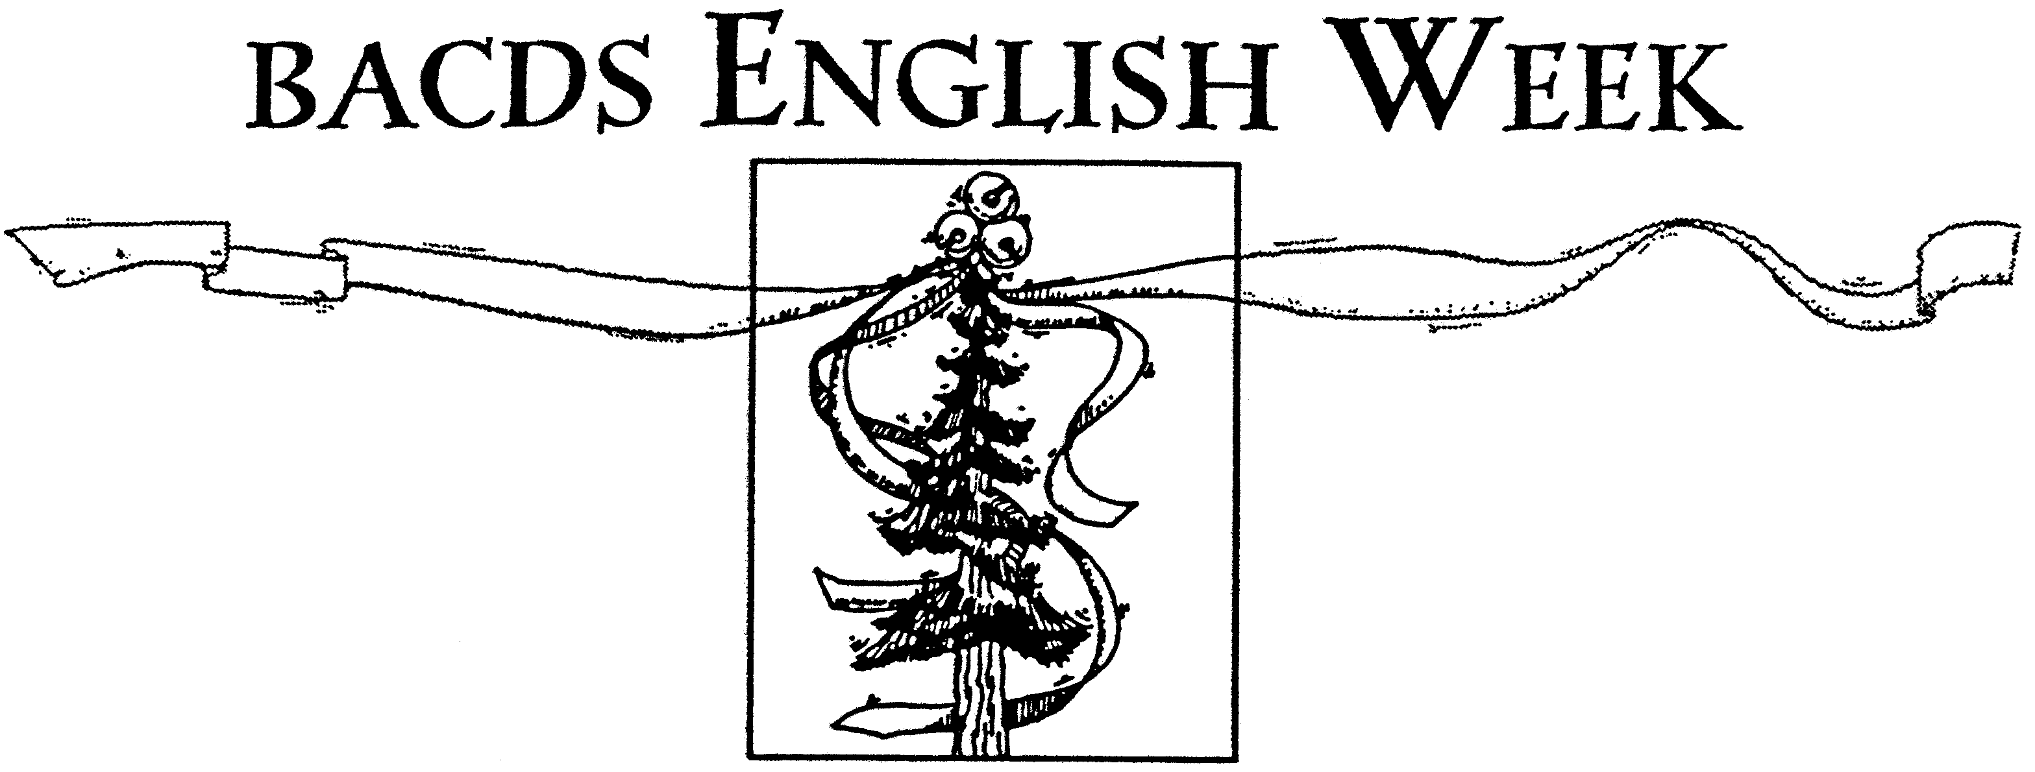

June 22, 2005

Dear Camper,

English Dance Week 2005 at the Mendocino Woodlands is around the corner! We hope the enclosed information sheets will be helpful to you in preparing for camp.

Reminders
• Camp opens at 4:00 p.m. on Saturday, July 9. Dinner will be served at 6:30 p.m. that evening and will be followed by an introductory meeting, staff introductions, and a dance. The week will close after breakfast on Saturday, July 16.
• Accommodations are rustic cabins shared by two persons and have no electricity. We will give you your cabin assignment upon your arrival at camp. There are no laundry facilities at camp, so bring plenty of clean, dry clothes for warm and cool weather.
• We will provide fragrance-free soap, shampoo, conditioner, and body lotion for all campers to use. Please see the green fragrance-free sheet for fragrance-free personal items to bring.
• Your camper job assignment, description, and instructions will be in your packet at camp.

Bookstore
The English Dance Week camp bookstore has a wide and interesting variety of offerings, from books, CDs, DVDs, and craft items by staff members to over six hundred items from the CDSS national store, representing artists all over the world. In addition to this huge array of music and books, you will find dance-related goods such as dance-themed cards, Morris bells and hankies, gift bags, jewelry, dance shoe bags, handmade soaps, mugs and hats bearing the Mendocino Woodlands logo, period-attire dolls, and a number of special items from the Jane Austen Centre in Bath, England. Shop early–many items are one of a kind!

You may browse and reserve your selections at the bookstore any time during daylight hours, using cloth bags we supply, and you may purchase your goods any time a bookstore staff member is in the store. The bookstore accepts cash or checks; we cannot process credit card sales. Please help BACDS by doing some of your annual gift shopping at the camp bookstore!

Auction
TWO Auctions are featured, one live and one silent. Auction income augments camp fees, helping to make camp financially more accessible to all. After expenses, remaining funds support all BACDS activities, including future camps.

(see other side for Parties)

Auction items may be intangible. Services such as private music or dance lessons are always welcome. Consider unique events such as serenades or concerts, offering custom-written dances or tunes, or catering a breakfast in bed. Desirable tangible items have included hard-to-find books, original artwork, handmade comestibles, and vintage dance clothing.

Please realize that for the Live Auction to be exciting and successful, we need bidders as well as goods. Rather than purchasing an item to donate, consider saving your money to spend at the auction!

Parties and Events

Sunday, July 10
• Late afternoon Beach Party segueing into a BBQ cookout dinner. Come in your bathing suit, flip flops, or your coolest Hawaiian shirt. BYO Beach Ball.

Monday, July 11
• After the dance: Pub Night at the Beggar's Opera Inn. Wear your 18th-century garb and, if you like, bring something to share: a song, poem, or story, and some bottles of your favorite brew.

Tuesday, July 12
• High Tea in the afternoon. Bring out your gloves, hats, pearls, teacups. (We have a few hats to share.) The Live Auction follows the dance.

Wednesday, July 13
• Camper Night. Our night to call and play for our own camper dance.
Thursday, July 14 (Bastille Day)
• Late afternoon party, "Mourning in the Afternoon," a Gorey theme party. Black and white are de rigueur. After the dance: Bastille Day dance party with French music and dance.

Friday, July 15
• Show and Tell, displays of what we learned in our dance and music classes.

If you have any questions, please contact me and continue to check the English Dance Week 2005 website http://www.bacds.org/camps/eweek2005 for updates.

Looking forward to meeting you all at camp!

Victoria Williams
Camp Manager
victoria@berkeley.edu
(510) 815-2415

